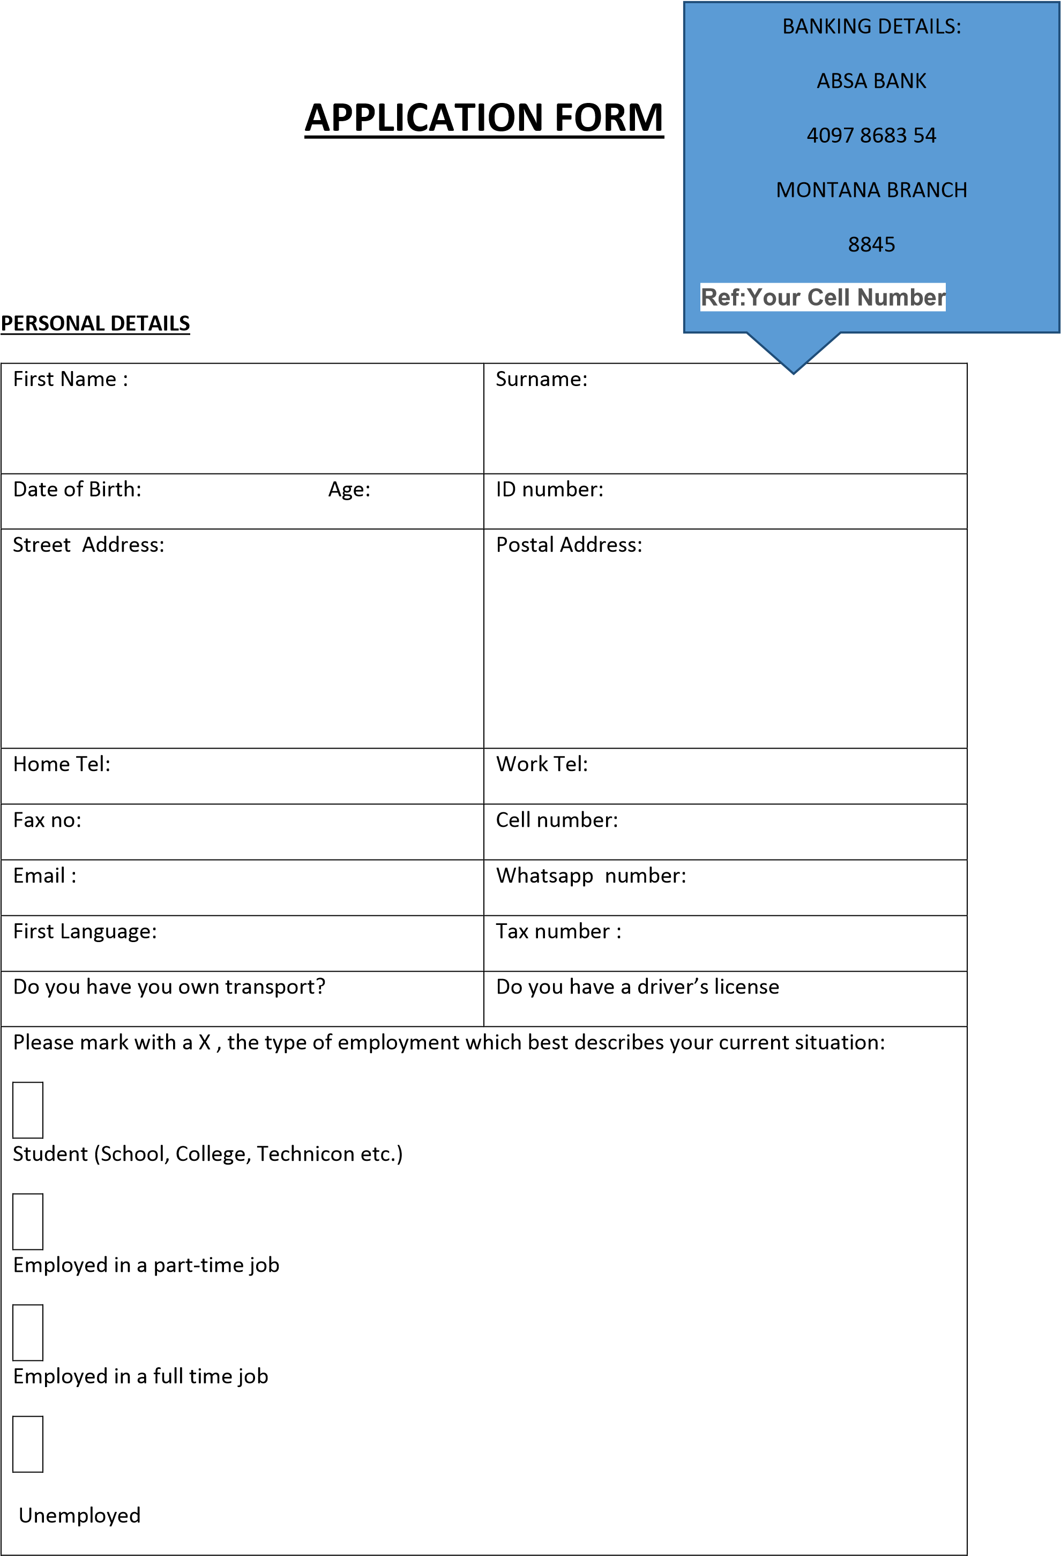

|  |  |  |
| --- | --- | --- |
|  |  | Other (please explain) |
|  |
|  | | |
|  | | |

**PHYSICAL FEATURES:**

|  |  |  |  |
| --- | --- | --- | --- |
| Height: |  | Weight: |  |
| Eye Colour: |  | Hair colour: |  |
| Dress/Shirt size: |  | Shoe size: |  |
| Your best features : |  | |  |
| Tattoos: |  | If yes where: |  |
| Piercings: |  | If yes where: |  |
|  |  |  |  |
| **Kids (under 7 years)** | **Students** | | **Ordinary members** |
| R900.00 once off | R1000.00 once off | | R1100.00 once off |
| OR R500.00 X 2 Months | OR R600.00 X 2 Months | | OR R650.00 X 2 Months |

|  |
| --- |
|  |

AGENCY / MEMBER AGREEMENT

…………Daxirite Casting Agency…………..

570 Fehrsen Street, Brooklyn Bridge, Stevens’ house, Brooklyn 0181

(HEREIN REFERRED TO AS AGENCY)

AND

…………………………………………………….

(HEREINAFTER REFERRED TO AS MEMBER)

For and in consideration of the mutual promises herein contained, the parties hereby agree as follow s.

For the term of this agreement, Member hereby appoints and engages Agency to act as Member’s e xclusive personal manager in the fields of Modelling, advertising, acting and entertainment. (Hereina fter referred to as the “fields”).

During the term hereof , Agency shall advice and counsel Member in the selection or consideration o f career opportunities , photographers ,advertisers ,castings and the selection or creation of vehicle of Member in any way and all matters pertaining to publicity ,public relations ,advertising talents of Member and shall advice Member on composites (comp cards) and the formation of portfolio.

Member agrees to seek Agency’s counsel in regards to all matters concerning Member’s endeavours in the fields. Member shall advice agency of all offers of employment submitted to Member and will refer all inquiries concerning Member’s services to Agency.

Agency is hereby granted the exclusive right to use and distribute and allow or license others to mak e use of and distribute Member’s name, portrait and pictures in connection with advertising and/or publicity of the member in the fields and in connection with the matter covered by the agreement.

Agency may publicize that it is the personal manager of the Member, and Agency may render similar services for others, and engage in other related business or ventures.

Member agrees to provide agency with current photographs, comp card tear sheets/advertising, wri tten or other related material for promotional use of the Agency and the Member.

Member shall pay to the Agency a sum of twenty five per cent (25 %) of all monies, fees or other con tributions received by Member directly or indirectly, under all contracts of employment entered into during the term specified in paragraph ten (10) and subsequently , paragraph eleven (11) , including reuse and residual whether originated by agency or not .

Member hereby grants to Agency a limited power of attorney to collect all fees and monies earned o r accruing to member from all sources governed by this agreement and to remit to member the net f ee after deducting the foresaid twenty five per cent (25) commissions.

This limited power of attorney includes the right of the Agency to deposit the proceeds in a general a ccount prior to remitting the balance to Member.

Member agrees to instruct the clients, producers, advertising agencies, production houses and/or un ion office in writing on the face of all job contracts or on the release, Member signs at the time of th e production to send all fees and monies due to the Member directly to the Agency.

This limited power of attorney also authorizes Agency to sign Member releases on behalf of the Me mber and authorize, reuse and residuals whether originated by Agency or not.

It is understood and agreed that Member is in business for himself/herself and is solely responsible f or payment of any and all taxes , whether income or otherwise .

It is further understood and agreed that Agency is acting as a personal manager only and does not o perate as an employment agency.

The term of this agreement shall be made for a period of two years (2 years), commencing this date. Member may terminate this agreement with 90 days written notice, delivered by registered mail to t he address listed on the face of this document.

If termination notice is received after a booking or placement has been arranged ,Member agrees to honour that booking /placement or else reimburse the Agency for any and all costs incurred or reven ue forfeited (including such revenue which may be owing to a client due to incurred expenses as a r esult of Member Cancellation.

In the absence of termination notice, this agreement shall continue to be renewed from year to year on anniversary date.

Member is aware that Agency is entitled to receive a service charge from some or all the clients who utilize Member’s services. Member and Agency agree that this service charge will not affect Member ’s reimbursement.

In acting as a Member’s personal manager, it is understood that Agency will use reasonable efforts t o assist Member obtain sub-agency placement outside province of Gauteng in such cases it is unders tood that with respect to such engagements, Member need not compensate Agency as provided in p aragraph seven (7) hereof, although it is understood that the Agency may be entitled to receive com pensation from such sub-agencies.

Member agrees to conduct himself/herself with propriety and dignity, to do nothing on an engagem ent or otherwise that may tend to injure the reputation and goodwill of Member or Agency, not to d o any act or thing which impairs Member’s capacity to all times fully comply with the terms of this ag reement, or which impairs member’s physical or mental qualities or abilities.

Member further agrees to abide by all standard rules and policies of casting and engagement. Agenc y may upon five (5) days’ notice to member terminate this agreement for breach of this paragraph.

Member understands and agrees that Member shall not , while this agreement is in force , enter any modelling/acting /advertising contests or competition organise or sponsored by any company other than that agency or sign and contest agreement unless Member has a written permission of Agency.

Waiver by either of the parties hereto of a breach of any of the provisions herein shall not be d dee med a waiver of any subsequently breach nor a modification of such provision.

It is understood and agreed that Member’s services are extraordinary and unique and there is no ad equate remedy at law of a breach of this agreement by Member and that in the event of such a brea ch or threatened breach, Agency shall be entitled to injunction or otherwise provided however that nothing herein shall construed as a waiver of any or all rights which Agency may have for damages in an action at law or in equity or otherwise.

This is covenant sets forth the entire engagement between parties. Should any provision(S) be held t o be void or enforceable, such provisions shall be deemed omitted and this agreement with such

provisions omitted shall remain in full force and effect.

No modification, alteration or amendments of any provisions contained herein shall be valid or binding u nless in writing by both parties hereto, both parties warrant that in entering into this agreement they ha ve not been induced by and are not relying on any promises, representations or warranties not set forth in writing. Member warrants that no other binding agreement is in force with any other party which sho uld supersede this agreement. This agreement shall be binding upon both parties hereto, their heir, succ essors, assigns etc.

BY SIGNING BELOW, BOTH PARTIES AGREE TO THE TERMS CONTAINED WITHIN THIS AGREEMENT AND A CKNOWLEDGE UNDERSTANDING OF THE TERMS OF THE CONTACT HEREIN.

|  |  |  |
| --- | --- | --- |
| MEMBER’S NAME |  | AGENT’S NAME |
| ………………………………………………………………… |  | …………………………………………………… |
| MEMBER’S SIGNATURE |  | AGENT’S SIGNATURE |
| ……………………………………………………………….. |  | ……………………………………………………. |

I/We the parents of ………………………………………………………………………………..who is a minor under the age of eighteen (18), have read the above agreement and acknowledge that both we and our son/daughter ……

……………………………..have entered into this agreement with an understanding of its terms and conditions

PARENT/GUARDIAN‘S NAME

……………………………………………………………………

PARENT / GUARDIAN ‘S SIGNATURE